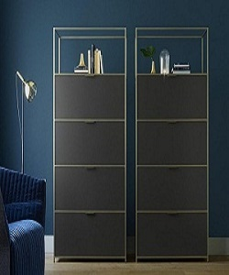

Divider

$130.71

Availability: In stock

Description:

Beautiful and 'The brilliant black color' it has 8 drawers and some storage place on of it,the matte look gives a on-tred look and feel. Available in different colors to make your home your ideal. this room divider can be used to define space in an open concept room, or can be set in front of a large window for privacy. Rounding out the design, metal hinges make folding and storage a breeze when not in use.